PRACTICE 4
Determine the validity of the following three statements. Circle either True or False.
- Group functions work across many rows to produce one result per group.
True/False
True
- Group functions include nulls in calculations.
True/False
False
- The WHERE clause restricts rows prior to inclusion in a group calculation.
True/False
True
The HR department needs the following reports:
- Find the highest, lowest, sum, and average salary of all employees. Label the columns
Maximum, Minimum, Sum, and Average, respectively.
Query: SELECT MAX(salary) "Maximum",MIN(salary) "Minimum", SUM(salary) "Sum", AVG(salary) "Average" FROM employees;
- Modify the query in lab_04 to display the minimum, maximum, sum, and average salary for each job type.
Query: SELECT job_id,MAX(salary) "Maximum",MIN(salary) "Minimum",SUM(salary) "Sum",AVG(salary) "Average"FROM employees
GROUP BY job_id;
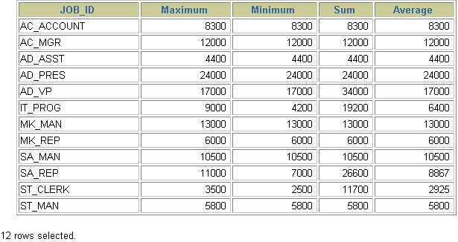
- Write a query to display the number of people with the same job.
Query: select job_id,count(*) from employees group by job_id
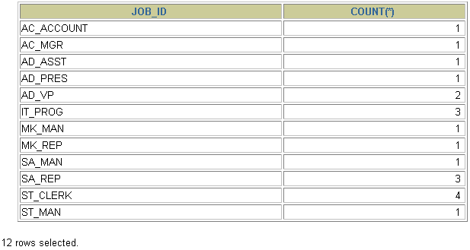
- Determine the number of managers without listing them. Label the column Number of Managers.
Query: select count(manager_id) "Number of Managers" from employees
- Find the difference between the highest and lowest salaries. Label the column DIFFERENCE.
Query: select max(salary)-min(salary) difference from employees

